H.T No
Regulations:
A15


Sreenidhi Institute of Science and Technology
(An Autonomous Institution)
Code No: 5B621 Date: 14-Dec-2018 (AN)

B.Tech III-Year II-Semester External Examination, Nov/Dec - 2018 (Supplementary)
CAD/CAM (ME)

Time: 3 Hours Max.Marks:75

Note: a) No additional answer sheets will be provided.
b) All sub-parts of a question must be answered at one place only, otherwise it will not be valued.
c) Missing data can be assumed suitably.

Part - A Max.Marks:25

Answer all QUESTIONS.

1. | What is meant by Product Cycle? Mention its importance. | [3M]
2. | Write the 3D transformation matrix for scaling, rotation and mirroring. | [3M]
3. | Compare B-representation with CSG representation in geometric modeling. | [3M]
4. | Write the block format for G02, G81 and G42. | [3M]
5. | Name the advantages and limitations of Production Flow Analysis. | [3M]
6. | Classify various types of manufacturing systems and compare them. | [2M]
7. | List various types of database models used in geometric modeling. | [2M]
8. | Name various types of display control commands used in drafting. | [2M]
9. | Mention various types of non-contact inspection methods used in CAQC. | [2M]
10. | Enumerate the various types of criteria used for selecting CAD workstations. | [2M]
Part – B Max.Marks:50
ANSWER ANY FIVE QUESTIONS. EACH QUESTION CARRIES 10 MARKS.

11. | a) | Briefly discuss the role of computers in a manufacturing scenario. | [5M]
 | b) | With a neat sketch explain the working of a Colour Raster Display System. | [5M]
12. | a) | Find the reflected coordinates of the triangle ABC about the line y = 3x + 4. The original coordinates of vertices of triangle are A(5,10), B (10,10) and C (5, 15). | [5M]
 | b) | Discuss about Bresenham's Line Generation Algorithm. | [5M]
13. |  | Mention the various methods of representing the solids. Create the CSG Model of the solid shown in Figure below:  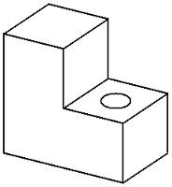 | [10M]
14. |  | What is meant by Canned Cycle? Illustrate its importance by writing NC part program with and without using canned cycle for the component shown in Fig. below.  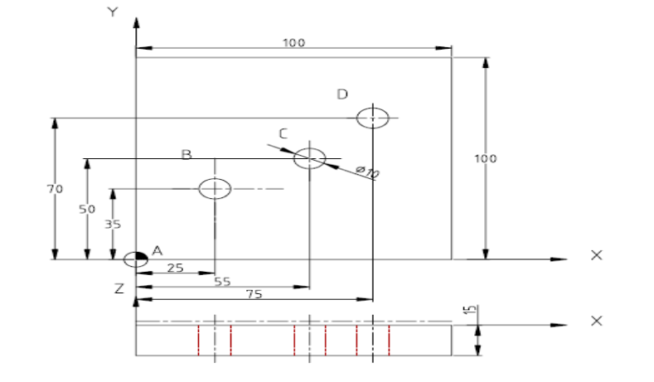 | [10M]
15. | a) | Develop the opitz form code (first 5 digit) with justification for the component  shown in Fig.  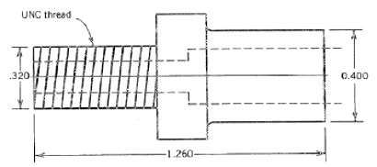 | [5M]
 | b) | Discuss the integration of CAQC with CAD/CAM. | [5M]
16. | a) | Discuss the benefits of Computer Integrated Manufacturing. | [5M]
 | b) | Explain the various principles of material handling systems. | [5M]
17. | a) | Name various types of input and output devices. | [3M]
 | b) | List various types of line clipping algorithms and mention their significance. | [4M]
 | c) | Mention various types of geometric commands. | [3M]
18. | a) | Write various types of geometric commands used in APT. | [3M]
 | b) | Discuss about retrieval type of CAPP System | [4M]
 | c) | Mention the role of human labour in manufacturing systems | [3M]
-- 00 -- 00 –

